 | 

TextMaker lets you create attractive documents of any size in no time. To help you get started, we have summarised some of the most important functions in this document. You can also use this document to record your own notes.

Create documents at lightning speed using attractive templates
Do you just want to write a letter? It couldn’t be easier: Click on the File | New Icon to go straight to the dialog box for selecting a suitable document template. In the “Business letters” or “Personal letters” folder, select a template and get started immediately:
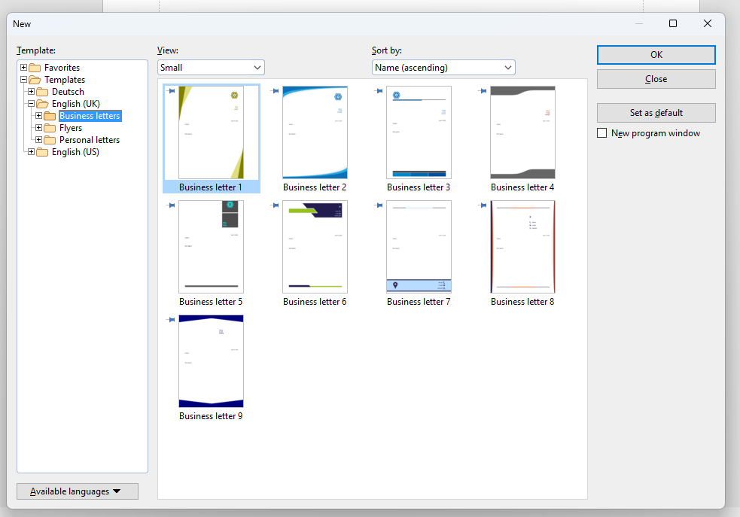
If you entered your address the first time you started TextMaker, it will now be used automatically in your document. If you haven’t done that yet, don’t worry about it as you can still do so using the User info button on the “General” tab under File | Options.

Format text according to your needs
Regardless of whether you open a document template, create a new document or open an existing file: TextMaker allows you to adjust the formatting of your text exactly to your needs. The quickest way to do this is to use the commands on the ribbon tab Home:
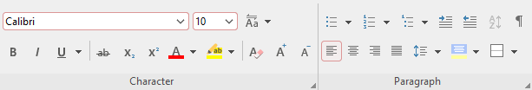
Select the text that you want to format and then apply the desired formatting by clicking on the appropriate icon.
Overview of some of the most important formatting commands:
Bold formatting (shortcut key: Ctrl+B)
Italic formatting (shortcut key: Ctrl+I)
Underline (shortcut key: Ctrl+U)
Text highlighting
Font colour
- Bulleted list
- Numbering

Tip: If you are creating a large document, you will probably want to format all headings, numbering, captions, etc. in consistent styles. In this case, we recommend using paragraph and character styles rather than working directly with the above commands. These styles can be found under Home | Styles or in the right sidebar.
If you like, you can try out the functionality of paragraph and character styles directly in this document. To do so, simply click to place the cursor in the following paragraph:
>> Click here to place cursor <<
Then right-click on Heading 1 under “Paragraph styles” in the right sidebar and select Update from text in the popup menu. You will see that all headings in this document now change their appearance in the same manner. Thus paragraph and character styles save you a lot of time, especially when working with larger documents.

Write with confidence – thanks to the automatic spell check
TextMaker ensures error-free sentences while you type. To enable the automatic spell check, simply select Check spelling as you type from the Spell check dropdown menu on the ribbon tab Review:
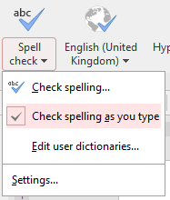
All spelling mistakes in your document are then automatically highlighted with a red underline. Right-click on the misspelt words to see alternative suggestions for the correct spelling or to add unknown terms to your user dictionary.

Enhance your document with images and objects
Would you like to illustrate your text with pictures? Do you want to convey important data with diagrams? Would you like to design your own layouts with drawings? It couldn’t be easier: The ribbon tab Insert provides a whole range of objects that you can include in your document:
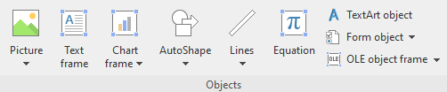
Simply select any object and click in your document to insert it.
Tip: Do you want to quickly add attractive colour and shadow effects to a drawing object (“AutoShape”)? Select it and take a look at the ribbon tab Object ribbon tab that appears: Here, you will find numerous presets for designing your drawing object under AutoShape templates and AutoShape effects.
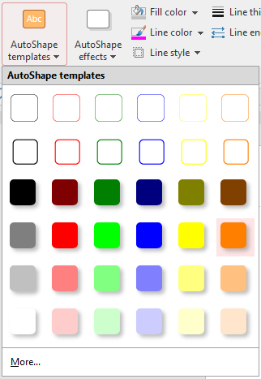
AutoShape templates
Try the following: Click to select the orange speech bubble and watch it change its appearance as you use the mouse to hover over the options of Object | AutoShapes templates.

Design sophisticated layouts in object mode
If you insert multiple objects (pictures, drawings, diagrams, etc.) into a document, TextMaker’s unique object mode ensures that you always have an overview. Once enabled, you can select and edit object frames with the mouse as usual, but not body text. This lets you avoid inadvertent text changes in documents containing lots of objects.
To enable object mode, click on the mouse cursor icon in the quick access toolbar below the ribbon:
Toggle text mode and object mode

Incidentally: It is not only the object mode that helps you to keep an overview of many objects. The navigator in the left sidebar is also very useful in this respect. Simply switch it to “Objects” mode using the dropdown menu under “Document content” and you will get a clear list of all pictures, drawings, tables, etc. in your document:
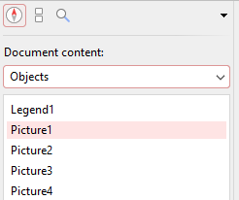
A click on the respective list entry is sufficient to select the desired object.

Save compatible documents
The first time you save a file in TextMaker, you will be asked whether you prefer DOCX or TMDX as the file format. If you regularly exchange files with Microsoft Word users, you may want to select DOCX, the standard Microsoft Word file format:
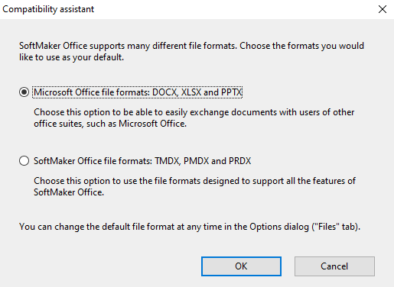
This enables Microsoft Word users to continue working on your documents directly – without prior conversion.

Return to previous file versions
You have probably experienced the following scenario: You have been working on a large document over a long period of time and want to return to an earlier editing status of your file after a while. It couldn’t be easier: TextMaker creates a new version of your document every time you save it. Automatic backups are also created at regular intervals.
With just one mouse click, you can return to any version. To do so, open the dropdown element File | Versions:
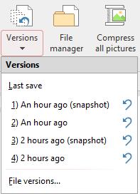
Click directly on one of the entries to open the desired file version in a new document tab, or click on the corresponding blue arrow to reset the file you are currently working on to the selected state.
By default, TextMaker creates up to nine manual and nine automatic versions per file before removing the oldest one. If you need more versions or if you want to reduce the maximum number of file versions, you can make appropriate adjustments under File | Options on the Backup tab.

Work with multiple documents simultaneously – as conveniently as in a web browser
Documents opened in TextMaker are always displayed clearly in individual tabs:
These tabs allow you to work in a way which is probably familiar from your web browser: Using drag and drop, you “take hold” of any tab and drag it to your desktop to open a new program window with the associated document. In the same way, you can return documents to a program window. This function is particularly useful if you have many documents open at the same time or are working with several screens because you can intuitively distribute your documents across different program windows and screens.

Here you can find additional information
We hope this quick start guide will give you an initial overview of the numerous features of TextMaker. More information on all program functions can be found in the manual and in the help file. You can access both by clicking on the small question mark icon in the upper right corner:
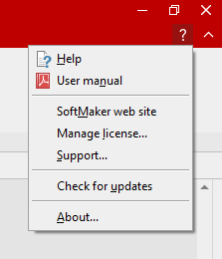
Tip: If you need help in relation to a specific function on the ribbon or in a dialog box, you can open the corresponding chapter of the documentation directly by positioning the mouse cursor over the command in question and pressing F1 on your keyboard.
We hope you continue to enjoy using TextMaker!
Your SoftMaker team

